



orth Staffs

**Speak Up Space instant messaging service**

Speak Up Space is a FREE confidential, safe instant messaging service for young people across Stoke-on-Trent. Available at [www.speakupspace.org.uk](http://www.speakupspace.org.uk)

Sundays 8pm-11pm Mondays 5pm-8pm

Tuesdays 8pm-11pm Wednesdays 5pm-8pm

Thursdays 4pm-9pm Fridays 8pm-11pm

Saturdays 8pm-11pm

**Maccas Zone**

Part of the Maccas Project, Maccas Zone is a free, confidential, and informal drop-in service supporting young people aged 14-18 years old who would like to improve their emotional wellbeing and benefit from some support. It meets fortnightly and no referral is required. For more information, email [maccasproject@nsmind.org.uk](mailto:maccasproject@nsmind.org.uk)

**For the latest information about our services visit** [**www.nsmind.org.uk**](http://www.nsmind.org.uk) **or follow us on Facebook @NorthStaffsMind**

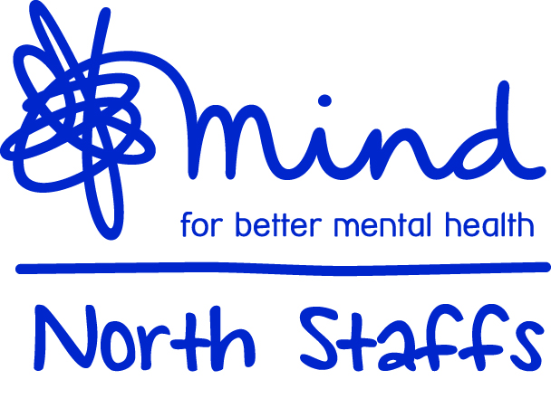

North Staffs Mind

83 Marsh Street

Hanley

Stoke-on-Trent

ST1 5HN

01782 262100

[reception@nsmind.org.uk](mailto:reception@nsmind.org.uk)

Registered Charity #700788

Registered Company in England #2294089

Wellbeing

Support

Summer 2021

1. A strengths-based Resilience Workshop that focuses on practical exercises/activities that you can apply to your daily lives to maintain a positive mental wellbeing.
2. One-to-one wellbeing support following your participation in the workshop. At the end of the sessions, we may signpost you to additional support available locally if this is needed.

**Adult Support Groups**

Tuesday Social Support Group for anyone over the age of 18

‘Be Excellent To Each Other’ – every Wednesday, suitable for males over the age of 18.

**Supported Housing**

For people over 18 who experience mental ill health and require some support in their daily lives to progress to more independent lifestyles. Contact our Housing Manager at [housing@nsmind.org.uk](mailto:housing@nsmind.org.uk) or 01782 824529.

**Children and Young People’s Services**

**Stay Well**

With Stay Well, North Staffs Mind, in partnership with Changes and the Dove Service, are providing easily accessible options for young people. One-to-one therapy via Zoom, online chat and/or telephone sessions, offered by experienced counsellors. Referral via 0300 123 0907

**Parent Support**

Parent Support offers parents and caregivers advice, guidance, support, interventions, and parenting strategies. Please call 01782 262100 and select Option 2, making sure that you leave your contact details and availability.

**Adult Services**

**Adult Counselling**

Our Adult Counselling service offers rapid access to counselling at an affordable cost, without lengthy waiting lists and at convenient times for clients. A number of reduced cost sessions are available each week to support those experiencing financial hardship. You can find out more, or book counselling by calling us on 01782 262100 or by emailing [reception@nsmind.org.uk](mailto:reception@nsmind.org.uk)

We also provide adult mental health services within the **Staffordshire and Stoke-on-Trent Wellbeing Service**. This brings together existing improving access to psychological therapies (IAPT) teams in the county into one, fully integrated service with a single point of access. The service can be contacted on 0300 303 0923 (Monday - Friday, 9am-5pm). More information is available at [www.staffsandstokewellbeing.nhs.uk](http://www.staffsandstokewellbeing.nhs.uk)

**Adult Instant Messenger Service**

Our Adult Instant Messenger Service is open every weekday 10am-1pm and 2-4pm. We offer an online chat about anything that is affecting your mental health and emotional wellbeing ***Please note this is not a crisis line.***

**Resilience Project**

Our Resilience Project aims to give local people the practical tools they need to maintain positive mental wellbeing. This project is to support those who are struggling due to the impacts of the coronavirus pandemic, whether you are experiencing poor mental health for the first time or have a longer-term condition and need some extra support.

It consists of two main activities:

