Year 4 Key Knowledge
These are very important facts that the children need to recall instantly, with little to no thinking time required. Keep working on these throughout the year.
Number bonds to 10  0 + 10 = 10 10 + 0 = 10 10 – 10 = 0 10 – 0 = 10 1 + 9 = 10 9 + 1 = 10 10 – 9 = 1 10 – 1 = 9 2 + 8 = 10 8 + 2 = 10 10 – 8 = 2 10 – 2 = 8 3 + 7 = 10 7 + 3 = 10 10 – 7 = 3 10 – 3 = 7 4 + 6 = 10 6 + 4 = 10 10 – 6 = 4 10 – 4 = 6 5 + 5 = 10 10 – 5 = 5 | Number bonds to 20  0 + 20 = 20 1 + 19 = 20 2 + 18 = 20 3 + 17 = 20 4 + 16 = 20 5 + 15 = 20 6 + 14 = 20 7 + 13 = 20 8 + 12 = 20 9 + 11 = 20 10 + 10 = 20 20 + 0 = 20 19 + 1 = 20 18 + 2 = 20 17 + 3 = 20 16 + 4 = 20 15 + 5 = 20 14 + 6 = 20 13 + 7 = 20 12 + 8 = 20 11 + 9 = 20 20 – 0 = 20 20 – 1 = 19 20 – 2 = 18 20 – 3 = 17 20 – 4 = 16 20 – 5 = 15 20 – 6 = 14 20 – 7 = 13 20 – 8 = 12 20 – 9 = 11 20 – 10 = 10 20 – 20 = 0 20 – 19 = 1 20 – 18 = 2 20 – 17 = 3 20 – 16 = 4 20 – 15 = 5 20 – 14 = 6 20 – 13 = 7 20 – 12 = 8 20 – 11 = 9
Time Facts  There are 60 seconds in a minute.  There are 60 minutes in an hour.  There are 24 hours in a day.  There are 7 days in a week.  There are 12 months in a year.  There are 365 ¼ days in a year.  There are 366 days in a leap year. | Number of days in each month  January February March April May June 31 28/29 31 30 31 30 July August September October November December 31 31 30 31 30 31  30 days has September, April, June and November. All the rest have 31 except for February which has 28 unless it is a leap year at 29.
Number bonds to 100  0 + 100 = 100 100 + 0 = 100 100 – 100 = 0 100 – 90 = 10 10 + 90 = 100 90 + 10 = 100 100 – 90 = 10 100 – 10 = 90 20 + 80 = 100 80 + 20 = 100 100 – 80 = 20 100 – 20 = 80 30 + 70 = 100 70 + 30 = 100 100 – 70 = 30 100 – 30 = 70 40 + 60 = 100 60 + 40 = 100 100 – 60 = 40 100 – 40 = 60 50 + 50= 100 100 – 50 = 50  Also, all the corresponding facts up to 1000.  E.G. 400 + 600 = 1000 | Number bonds to 100 that are not multiplies of 10  These are a few examples.  75 + 25 = 100 25 + 75 = 100 100 – 25 = 75 100 – 75 = 25 37 + 63 = 100 63 + 37 = 100 100 – 63 = 37 100 – 37 = 63 48 + 52 = 100 52 + 48 = 100 100 – 52 = 48 100 – 48 = 52
Other number facts.  4 lots of 25 = 100  5 lots of 20 = 100  10 lots of 10 in 100  100 lots of 10 in 1000  10 lots of 100 in 1000  10 lots of 1000 in 10, 000 |  | Multiplication help.  Double = x 2  Double, double = x 4  Double, double and double = x 8  Halve = divide by 2 etc.
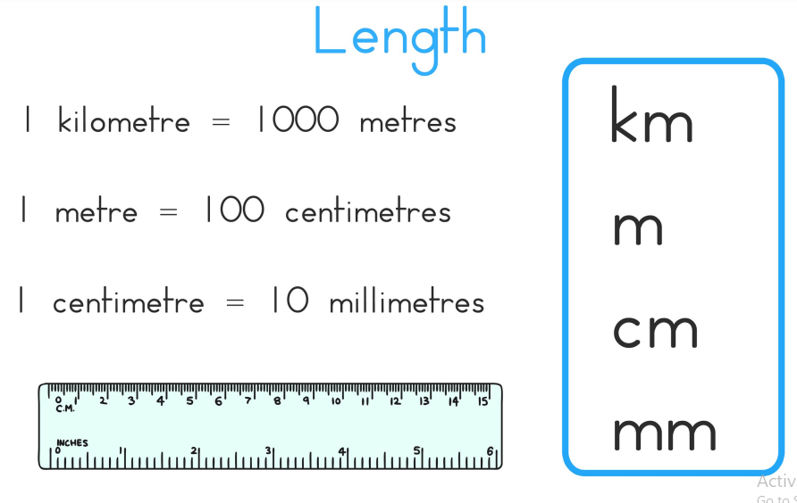 | 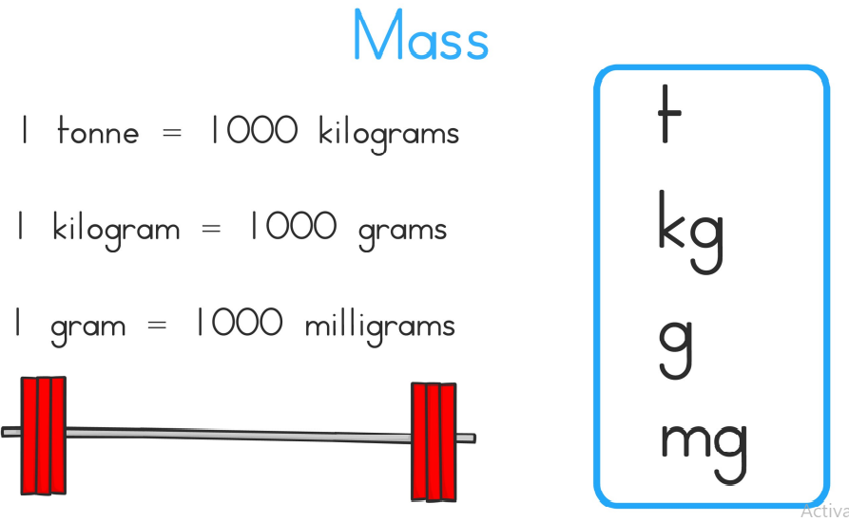
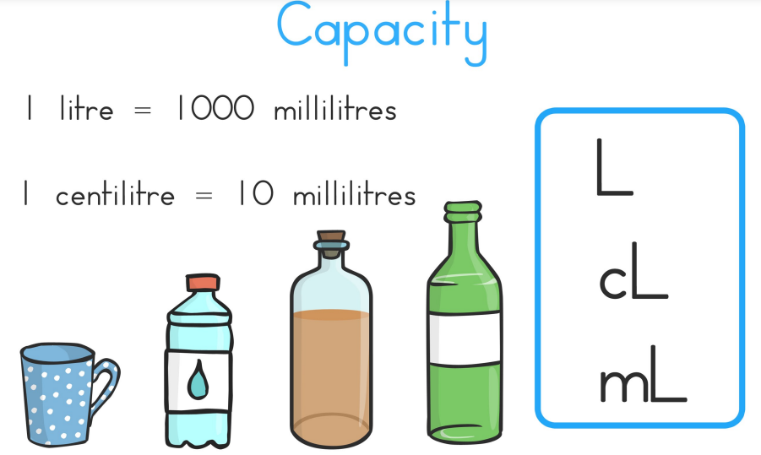

Websites you can visit.

- Maths - Topmarks Search
- Times tables worksheets printable - Math worksheets
- Measurement - KS2 Maths - BBC Bitesize BBC Bitesize has a range of videos and activities linked to all primary topics.
- Activities for 9-12 years | Words for Life. Literacy activities
- http://www.bbc.co.uk/bitesize/ks2/english/spelling_grammar/
- http://www.funbrain.com/grammar/
- http://learnenglishkids.britishcouncil.org/en/grammar
- http://resources.woodlands-junior.kent.sch.uk/interactive/literacy2.htm
- http://www.crickweb.co.uk/ks2literacy.html
- http://www.grammar-monster.com

