
St. John’s CE Primary School
Mill Lane, Wetley Rocks, Stoke-on-Trent, Staffordshire, ST9 0BN
Telephone: 01782 550309
www.st-johns-wetleyrocks.staffs.sch.uk
Email: office@st-johns-wetleyrocks.staffs.sch.uk
Head of School: Sarah Stone

Dear Parent/Carer,

As part of our science topic, Year 4 and 5 will be visiting THINK TANK, the science museum in Birmingham on Tuesday 27th June 2023. The trip will last all day and to ensure that we reach the science museum by 10.00am, the children will need to be in school at 8.30am to be ready to board the coach for 8.45am. It is important that you bring your child at these times as we cannot wait around. The science museum asks that we move around the exhibits at set times and we must start at 10.00am. The trip will last all day and we will leave the science museum at 2.15pm. Due to traffic, we could potentially be back later than 3.30pm. We will keep you updated on our progress via text message.

The children will need to wear their full school uniform and bring a hat if it is sunny. Part of the museum is outside. All children will also need a packed lunch. If you receive free school dinners, please contact the office by 16th June to order your child’s packed lunch.

Due to the organisation of day, and the fact that there are a number of school groups visiting during June, they have asked us to pre-order any items from the gift shop. This means we will not be visiting the gift shop on the day. Please find attached the list of items that your child can pre-order. If you do not pre-order, they will not be able to go to the gift shop on the day. Please limit your purchases to £5. The gift shop will make up all the gift bags and we will distribute them when the children return to school. Please complete your goodie bag order by the 21st June with the exact payment in cash. Any payments after this time will not be processed by the museum. Please give your order to the teacher, not the office staff.

Many thanks,
Mrs. R Poynton and Mrs. E. Oakden

Thinktank, Birmingham Science Museum Shop
Group Goodie Bag Order Form

Items
Planetarium Pencil  90p | 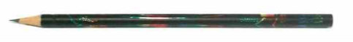
Thinktank Pencil

60p
Mini Grip Pen  75p | 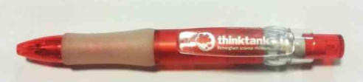
Thinktank Pen  £1.00 | 
Multiwriter Pen  £1.75 | 
Fridge Magnet  £2.50 | 

Notepad & Pen  £2.50 | 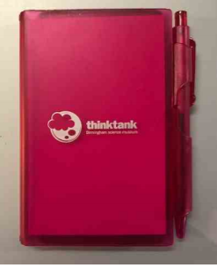

Fleur Highlighter  £1.99 | 
Thinktank Button Badge  £0.75 | IMAGE COMING SOON
Rainbow Eraser  £0.60 | IMAGE COMING SOON
Plastic Spring  £2.50 | 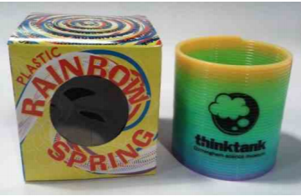
Exclusive Thinktank Top Trumps  £3.50 | 
ORDER

Item | Price (each) | Quantity | Total
Planetarium Pencil (2889) | 90p
Thinktank Pencil (700418) | 60p
Mini Grip Pen (3223) | 75p
Thinktank Pen (700417) | £1
Multi Writer Pen (700416) | £1.75
Thinktank Fridge Magnet (700009) | £2.50
Notepad & Pen (703003) | £2.50
Fleur Highlighter (7171) | £2.50
Thinktank Button Badge (6028) | 75p
Rainbow Eraser (703741) | 60p
Plastic Spring (700041) | £1.50
Thinktank Top Trumps (703318) | £3.50
 |  | Total:

