Overview
Detail | Information
Academic year that this summary covers | 2025 to 2026
Date this summary was published | September 2025
Date this summary will be reviewed | September 2026
Name of the school music lead | Mrs. Poynton
Name of school leadership team member with responsibility for music (if different) | Mrs. Poynton
Name of local music hub | The Music Partnership – Entrust Music Service, Staffordshire
Name of other music education organisation(s) (if partnership in place) | Stoke on Trent School of Rock

This is a summary of how our school delivers music education to all our pupils across three areas – curriculum music, co-curricular provision and musical experiences – and what changes we are planning in future years. This information is to help pupils and parents or carers understand what our school offers and who we work with to support our pupils’ music education.

Part A: Curriculum music
This is about what we teach in lesson time, how much time is spent teaching music and any music qualifications or awards that pupils can achieve.
St. John’s Academy and Nursery holds the teaching of Music and the Arts in high esteem and champions the equitable teaching of high-quality music to all children regardless of need.
Curriculum music lessons are part of our core offer at St John’s. Our curriculum has been built progressively using Kapow as our scheme of work. “Our music curriculum has always been designed around strands, derived from the National curriculum aims and other government guidance. Teaching is split into the following strands:
- Listening
- Creating Music
- Notation
- Improvisation and Composing
- Performing

The introduction of "Creating sound" as a separate strand (previously part of "Performing") aims to clarify progression in this vital component of musical development. According to the Striking the Right Note - the Music Subject Report (Ofsted, 2023), the most effective music teaching in schools involves gradually enhancing pupils' skills in controlling sounds, whether through singing, playing instruments, or using music technology.” Kapow 2025

These strands are essential for mapping out how students progress in different aspects of music. This allows all children to explore children a range of musical genre through five elements: listening, instrumental, notation, improvision/composing and performance.
Lessons consist of a range of learning opportunities:
- Listening – exploring a range of musical styles and genres from around the world and from different periods of music. This includes visually watching performances both via the internet and more importantly through watching live performances where possible.
- Whole class instrumental teaching facilities allow children to utilise their voice or individual instruments (percussive instruments, glockenspiels and recorders) and enable children to begin to read music progressively from a stave in addition to exploring improvisation and more formal composition methods.
- Notation ensures that there is no confusion.Music is a universal language that has the power to evoke emotions, tell stories, and bring people together. Whether you are a beginner learning to play an instrument or a seasoned musician composing your own pieces, one crucial aspect of music that cannot be overlooked is proper notation. Accurate note placement plays a vital role in conveying the composer’s intentions and ensuring that the music is performed correctly.
- Improvisation provides children with the freedom to sing or play instruments to explore their own creative talents. Composing facilitates opportunities for children to work individually and as both a small and large group to make music together.
- “Performing provides pupils with a practical reason to hone and apply their musical skills. It promotes group practice and collaboration, as pupils work together to achieve an aim. This experience not only boosts pupils' confidence and self-esteem but also enhances their awareness of themselves and others within the group.” Kapow 2025

Curriculum lessons are weekly for all children:
• EYFS/KS1 – 30 minutes per class
• KS2 – 45 minutes per class
EYFS lessons will link to their current topic and may be broken up into smaller sections so that children can link it to other areas of learning.
Year 1-6. The children will have a 45-minute lesson timetabled during the week. This will focus on the music curriculum skills that are taught. The progression of these lessons can be found on our website.

KAPOW statement: Our Music EYFS (Reception) units are not designed to be taught in a set order. Instead, they feature flexible, small-step activities, allowing teachers to personalise lessons to fit in with their chosen themes or topics. The ‘Celebration music’ unit consists of lessons which could be taught throughout the year when studying the festivals Diwali, Hanukkah, Kwankzaa and Christmas.
The six units are as follows: Exploring Sound, Celebration, Music and Movement, Musical Stories, Transport and Big Band.
All other Year groups follow the Kapow long term plan.
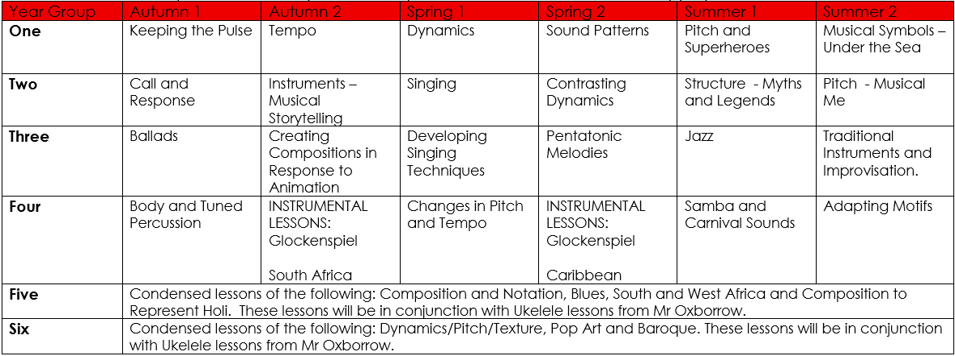
To enable the children to understand music further, all classes will have access to the recommended listening lists. The children will listen to this music at different points during the day. Thus, ensuring they have access to a wide range of genres of music.
During this academic year, Year 5 and 6 will be having weekly ukelele lessons with the prospect of expanding individual music lessons to all year groups over the coming years.
Year 4 will also undertake 1 term of lessons on the glockenspiel. Kapow provides a scheme for the children to work from. This will replace 2 of their units within the long-term scheme of work.
Within the school year, the school holds a termly music shows to showcase the talents of the children who undertake music lessons with Mrs Cowdy and Mr Oxborrow.
The school choir perform during our termly church services and have taken part in events at Victoria Hall Stoke-on-Trent.
Alongside our music curriculum, we also offer a broad and expansive opportunities for extra curriculum musical experiences.

Part B: Co-curricular music
This is about opportunities for pupils to sing and play music, outside of lesson time, including choirs, ensembles and bands, and how pupils can make progress in music beyond the core curriculum.
Outside of core music curriculum, we offer a range of musical opportunities.
In school we offer weekly:
- Violin lessons
- Keyboard lessons
- Drum lessons
- Ukulele lessons
- Recorder lessons
- Guitar lessons
Individual instrumental lessons are taught throughout the school day based on peripatetic music teachers’ timetable. Lessons are taught individually or grouped into small groups based on ability.
Instrumental tuition is paid for by parents. However, pupils who are in receipt of pupil premium can access these at a much-reduced rate. There is no cost to children and families for instrumental hire.
Miss Parish runs a school choir once a week. This choir perform during assemblies, church services and other activities that we can attend.
Miss Parish also runs a recorder club during one lunchtime session a week. Any pupil in KS2 can take part.
All children wishing to learn an instrument or join an ensemble at St John’s can do so regardless of age or any other factors. Parents are encouraged to speak to the school if they can see personal barriers that may prevent their children from accessing musical experiences in school.

Part C: Musical experiences
This is about all the other musical events and opportunities that we organise, such as singing in assembly, concerts and shows, and trips to professional concerts.
To further enhance our children’s exposure to music from around the world and various musical genres and styles, St. John’s Primary Academy and Nursery offers a range of music opportunities.
Collective Worships offer a chance to share, discuss and perform music. Our weekly singing assemblies allow all children to participate in group singing.
All children in St. John’s Primary Academy and Nursery are given the chance to perform in a show hosted by the school. Traditionally, EYFS and KS1 put on a production in the Autumn Term linked to the Nativity. Furthermore, UKS2 put on a Summer Term show. These are performed several times, and we welcome our parents and local community in to enjoy these performances.
As the children get older, additional roles are taken on by the children in the school around stage production, lightening, sound effects and set design.
We also hold regular church services at St. John’s the Baptist Church. Here, the children are expected to sing, perform and take part in the celebration of God. Parents and the local community are also invited to join in with our celebrations.
The school also run a termly music concert to showcase the talents of the children who undertake additional music lessons within school.
The school choir also take part in events at Victoria Hall Stoke-on-Trent.

In the future
This is about what the school is planning for subsequent years.
In the future, St. John’s would like to improve the quality of our music provision by working with the Local Music Hub to enable the following objectives to be achieved:
- We aim to continue to develop a music curriculum which empowers all teachers, both specialist and non-specialist to deliver high-quality lessons in which all pupils can achieve their potential.
- In 2025 -2026 we intend to purchase a whole class set of tuned and untuned instruments to improve the teaching of music.
- Access and attend an increasing number of live music events.
- Have funded events from visiting musicians.
- Participate in more local events that showcase our children’s talent.
- In future years, we aim to achieve a Music Mark membership.

