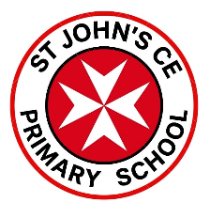
Safeguarding Update
6th January, 2026
Dear Parents/Carers,
We have been made aware that several titles in the ‘According to Humphrey’ series contain a weblink at the back of the book that no longer directs people to information about the books. Instead, the link has been compromised and now leads to inappropriate and unsafe material that should not be accessed by children at any age.
Below are images of some of the front covers in the series to help you identify the books should you have any at home. The link can be found on the back cover or may be also included on a page inside.
For clarity and reassurance, we are not aware of any children who have accessed this link at our setting. We have already completed a search of the school and have found no copies of the book in our library or classroom readding areas.
Actions and Next Steps:
- If you have any of these books at home, we advise you to remove them immediately. Should any be the property of the school, you can return them and we will dispose of them accordingly.
- Be extra-vigilant with all children’s books that contain links and ensure that they are checked by an adult.

Thank you to the parent who raised this with us, and to all our families for being such strong partners with the school. We are grateful for your continued support in working together to keep our children safe.
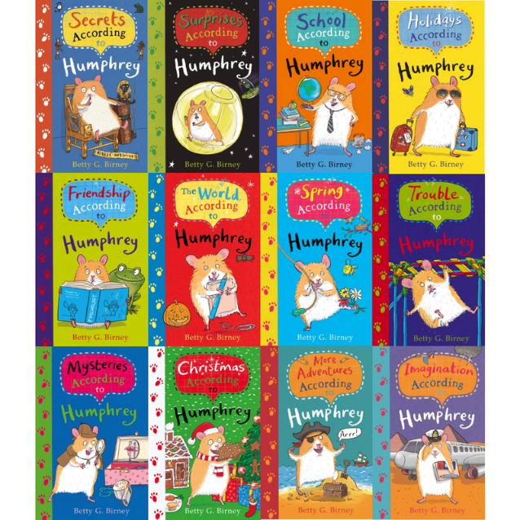
Best wishes
Mrs Stone

